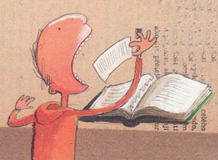

Anchor Chart:

**CHoMP**

**How do I take during-reading research notes?**





4.

3.

M

2.

H

**H**ighlight the important information text in the remaining text.

**P**ut the notes in your own words.

P

**M**ake notes based on the highlighted information by abbreviating, truncating, using symbols, and drawing instead of writing complete sentences.

**C**ross out small words, like prepositions and conjunctions (i.e. “a,” “the,” “and,” “but,” “yet,” “in,” “on,” etc.).

C

1.