Does My Goldfish Know Who I Am?

Asked by Shauna, age 10.

Dr. Mike Webster, biologist, says:

I think this is a great question, but then I do spend my days studying how fish go about their lives. First of all, fish are much smarter than people give them credit for. People often talk of goldfish having three-second memories, but actually they can learn all kinds of things, and remember them for quite a long time.
This shouldn’t surprise us too much. Just like other animals, they have evolved to find enough to eat, and to know when it is safe to be out in the open. Being able to learn and remember things helps them do this.
Many kinds of fish can tell each other apart, too. They recognise other fish from their shoal, their relatives, and even their own eggs. But fish live in a very different world from us. For many kinds of fish, although seeing is important, sense such as smell and touch are even more important.
So, does your fish know who you are? I’m sure your fish will certainly know what it is feeding time. My own fish become very excited when I open up the lid on their tank and my hand appears, even before I drop the food in. I’m not sure that your fish would be able to remember what your face looks like, but I wouldn’t be too surprised if it couldn’t recognise you in other ways, perhaps by the sound of your footsteps as you walk towards the tank.

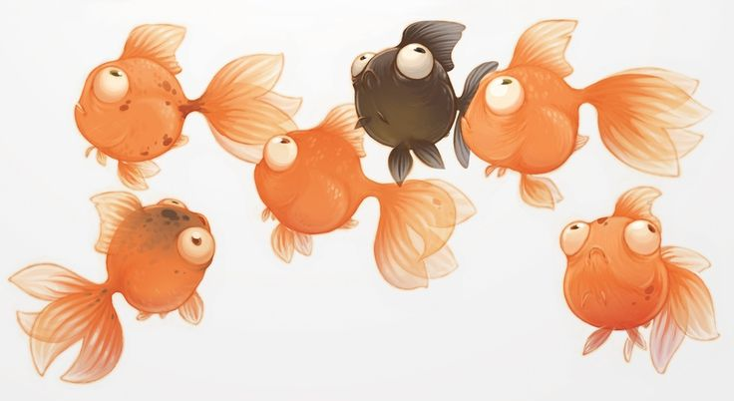

Webster, M. (2013). Does my goldfish know who I am? In Harris, G. H., Does my goldfish know who I am? And hundreds more big questions from little people answered by experts, (p. 94-95). London: Faber and Faber Limited.

