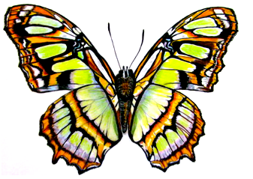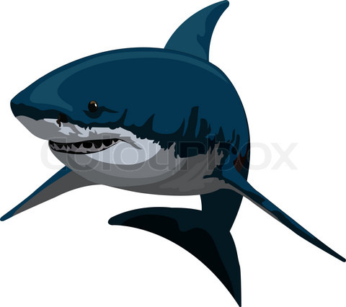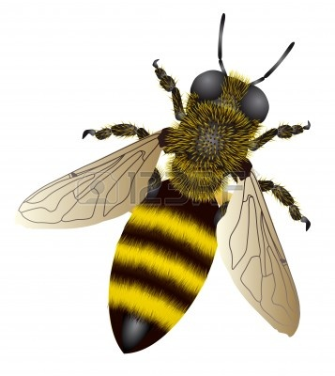

**I MATTER BECAUSE. . .**

**I MATTER BECAUSE. . .**

**I MATTER BECAUSE. . .**